Chapter 14, Problem 85.

Use PSpice to obtain the magnitude and phase plots of V_{o}/V_{s} of the circuit in Fig. 14.102.

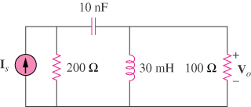

Figure 14.102
For Prob. 14.85.

